USE CASE DOCUMENTATION

Requirement ID | REG_01
Module Name | Customer module
Use Case Name | REGISTER
Use Case Description | Here using the use case, the Customer will register to the site.
Primary Actor | CUSTOMER
Use case Diagram | 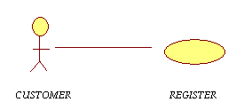
Basic flow | - Open the site.  - Signup for new registration.  - Fill the profile.  a. Enter name  b. Enter Login Id  c. Enter password  d. Confirm password  e. Enter DOB  f. Enter contact no.  g. Enter email id  h. Enter postal address  4. Clicks on “OK” button.
Input | - Name  - Login Id  - Password  - DOB  - Contact no.  - email Id
Output | Acknowledgement message stating the confirmation of registration.
Alternate Flows | Mail_ID entered wrongly.  - Display the message asking the user to enter existing mail_ID.  - User enters the correct mail _ID.  - Clicks on OK button.
Special instructions | Password length should be at least ‘6’ characters.

Requirement ID | LI_02
Module Name | Customer, Sales person, Warehouse employee
Use Case Name | LOGIN
Use Case Description | Here using the Use case the customer will LOGIN to the site to add products into his cart.
Primary Actor | CUSTOMER, SALES PERSON, WAREHOUSE EMPLOYEE
Use case Diagram | 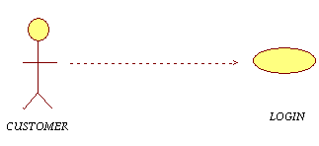
Precondition | To LOGIN, the customer must be registered with the complete details.
Basic Flow | - Customer Login the system.  - Enter username.  - Enter Password.  - Clicks on “OK” button.
Input | - Username  - Password
Output | Opens the home page of the site to view or add or remove or purchase the products.
Alternate Flows | - Password entered wrongly.  1. a Display the message asking the user to enter correct password.  1. b Customer corrects the password.  1. c Clicks on “OK” button again.  2. Customer forgets to enter the username.  2.a Display the message asking the user to  Enter username.  2. b Customer enters the username.  2. c Customer clicks on “OK” button again.
Special instructions | Enter correct username and password.

Requirement ID | VP_03
Module Name | Customer module
Use Case Name | VIEW THE PRODUCTS
Use Case Description | Here using the use case, the Customer will view the products to buy.
Primary Actor | CUSTOMER
Usecase Diagram | 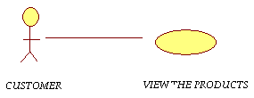
Precondition | - User must have an account.  - Products details must exist in the system.
Basic Flow | - Customer login to the site.  - Enter username  - Enter password  - View the list of products by products category
Input | - Login to the site  - Enter username  - Enter password
Output | View the list of products by products category.

Requirement ID | PO_04
Module Name | Customer module
Use Case Name | PLACES ORDER
Use Case Description | Here using the use case, the Customer will add the products to the cart.
Primary Actor | CUSTOMER
Use case Diagram
Precondition | - Customer must have an account.  - Products details must exist in the system.  - Customer must know the price range.
Post condition | Order successfully submitted.
Basic flow | - Customer login to the site  - Clicks on view the products link  - Places order to the sales person  - Add item to the cart  - Remove item from cart  - Review the contents of the cart  4. Click “OK” button
Input | - View the products  - Add the items to the cart
Output | Display the list of products which are added to the cart

Requirement ID | LO_05
Module Name | Customer, Sales person,
Use Case Name | LOGOUT
Use Case Description | Here using the use case, the Customer will log out from the site.
Primary Actor | CUSTOMER
Use case Diagram | 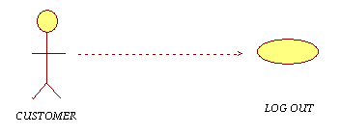
Precondition | - Customer must have an account.  - Customer must login to the system.
Post condition | Successfully logout from the page.
Basic flow | - open the site  - Enter username  - Enter password  - View different links on the page  - Click on required link  - Buy products online  - if not satisfied with the existing products  - Clicks on log out link
Input | - Required URL  - LOG IN  - username  - Password  - LOG OUT
Output | - Log out from the page  - Click on CLOSE button to come out of the site.

Requirement ID | RO_06
Module Name | Sales person module
Use Case Name | RECEIVES ORDER
Use Case Description | Here using the use case, the Sales person receives order from customer.
Primary Actor | SALESPERSON
Use case Diagram | 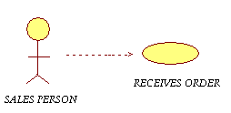
Precondition | Customer must place order
Basic flow | - Open the system  - Enter URL  - Enter username  - Enter password  - Clicks on Receive order  - Delivers order to the respective customer
Input | - URL  - Username  - Password
Output | Corresponding screen will be displayed.

Requirement ID | NW_07
Module Name | Sales person module
Use Case Name | NOTIFY WAREHOUSE ABOUT ORDER
Use Case Description | Here using the use case, the Sales person notifies warehouse about customer order.
Primary Actor | SALES PERSON
Use case Diagram | 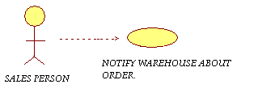
Precondition | Customer must place order to the sales person.
Post condition | Successfully updated.
Basic flow | - Open the system  - Enter URL  - Enter Username  - Enter Password  - Clicks on “OK” button  - View various links on the page  - Clicks on required link
Input | - URL  - Username  - Password
Output | Sales person clicks on notify warehouse about order i.e., inform warehouse about the order placed by the customer.

Requirement ID | MNGP_08
Module Name | Warehouse employee module
Use Case Name | MANAGE PRODUCTS LIST ONLINE
Use Case Description | Here using the use case, the warehouse employee manages the products list online.
Primary Actor | WAREHOUSE EMPLOYEE
Use case Diagram | 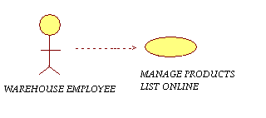
Precondition | - Shop must load new products to update information to the site  - To increase sales new offers must be implemented such as discounts etc.,
Post condition | Warehouse employees create, update and delete the latest information to the site.
Basic flow | - Login to the system.  - Warehouse employee updates the products information.  - View the list of existing products.  - Update the latest information.  - Exit from the page.  - Ware house employee delete the products information  - View the list of existing products.  - Delete the information  - Exit from the page.
Input | - URL  - Username  - Password
Output | Manage successfully.

Requirement ID | VR_09
Module Name | Warehouse module
Use Case Name | VIEW INFORMATION OF NEW REGISTRATIONS
Use Case Description | Here using the use case, the warehouse employee will manage the customer registration details.
Primary Actor | WAREHOUSE EMPLOYEE
Use case Diagram | 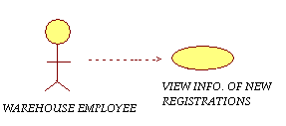
Precondition | Customers should be registered to the site.
Basic flow | - Enter URL  - Enter Username  - Enter Password  - Clicks on “OK” button  - Opens the page of various links  - Perform required operation
Input | - URL  - Username  - Password
Output | - Warehouse employee will get a screen about new registrations.  - Else no new registrations existing.

Requirement ID | US_10
Module Name | Warehouse Module
Use Case Name | UPDATE ORDER STATUS
Use Case Description | Here using the use case, the warehouse employee can update the order status.
Primary Actor | WAREHOUSE EMPLOYEE
Use case Diagram | 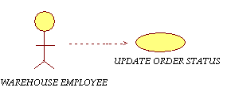
Precondition | - Customer must place an order.  - Order details must exist in the system.
Post condition | Update has been done successfully.
Basic flow | - Open the system  - Enter URL  - Enter Username  - Enter Password  - Clicks on “OK” button  - Opens the page of various links  - Perform required operation
Input | - URL  - Username  - Password
Output | Sales person updates information of the products and special offers which has to be implemented.

